DriverPass System Design Document – Leland Hamilton

UML Diagrams
UML Use Case Diagram

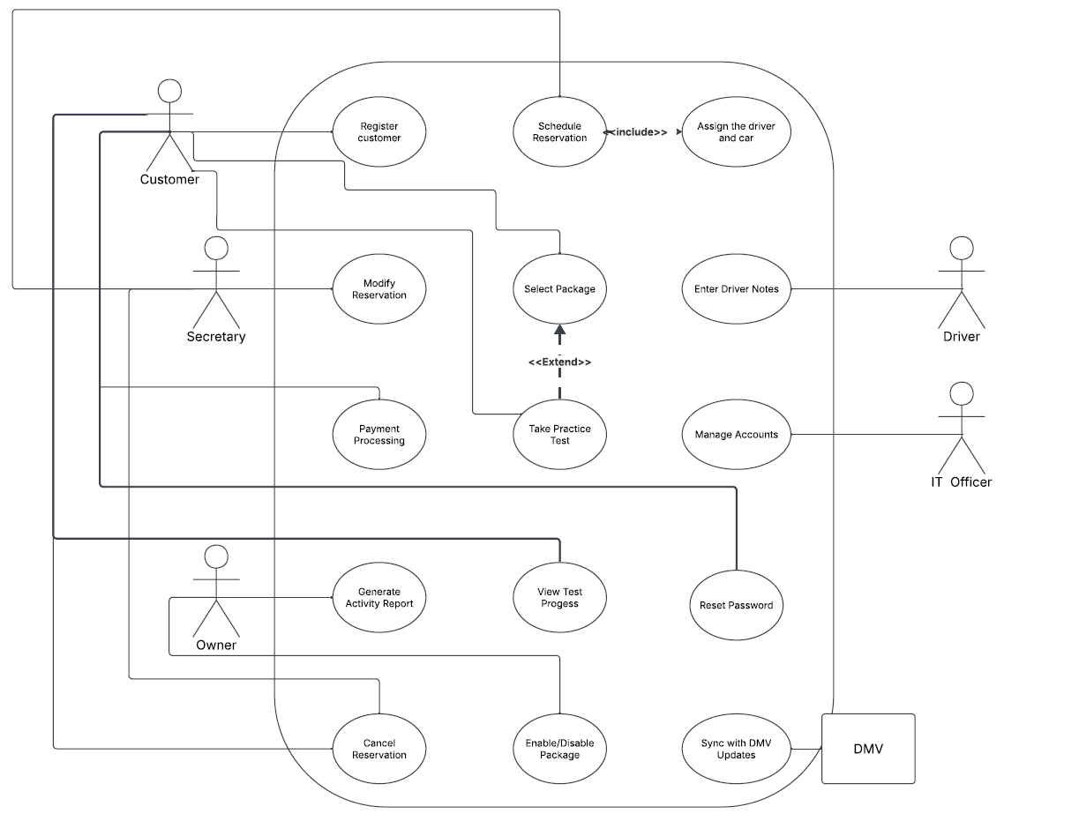

UML Activity Diagrams
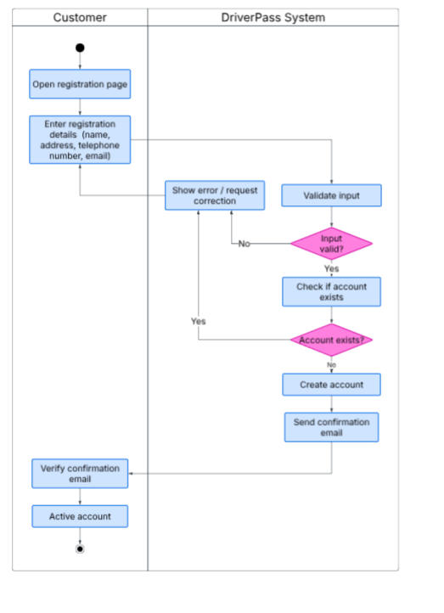

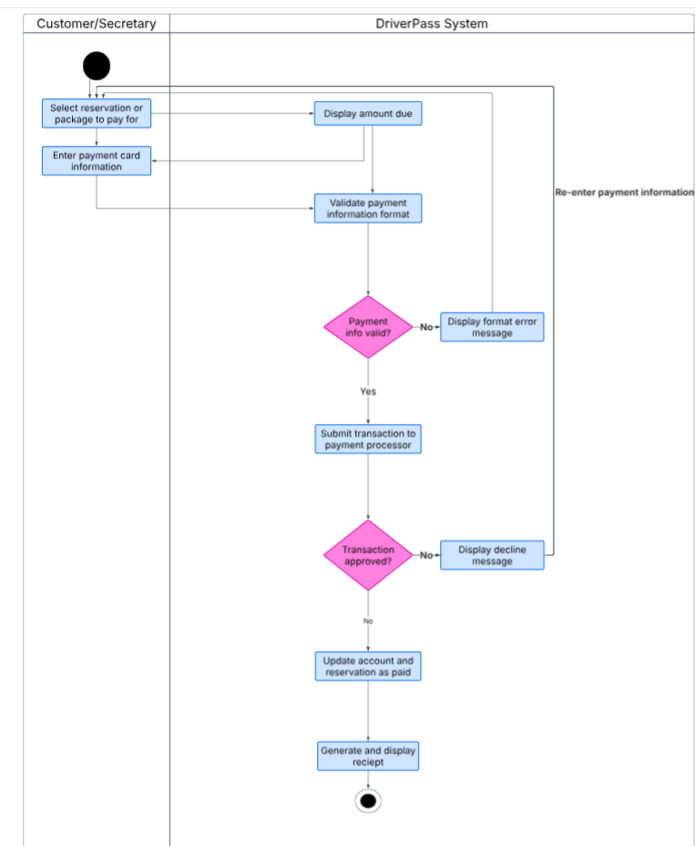
UML Sequence Diagram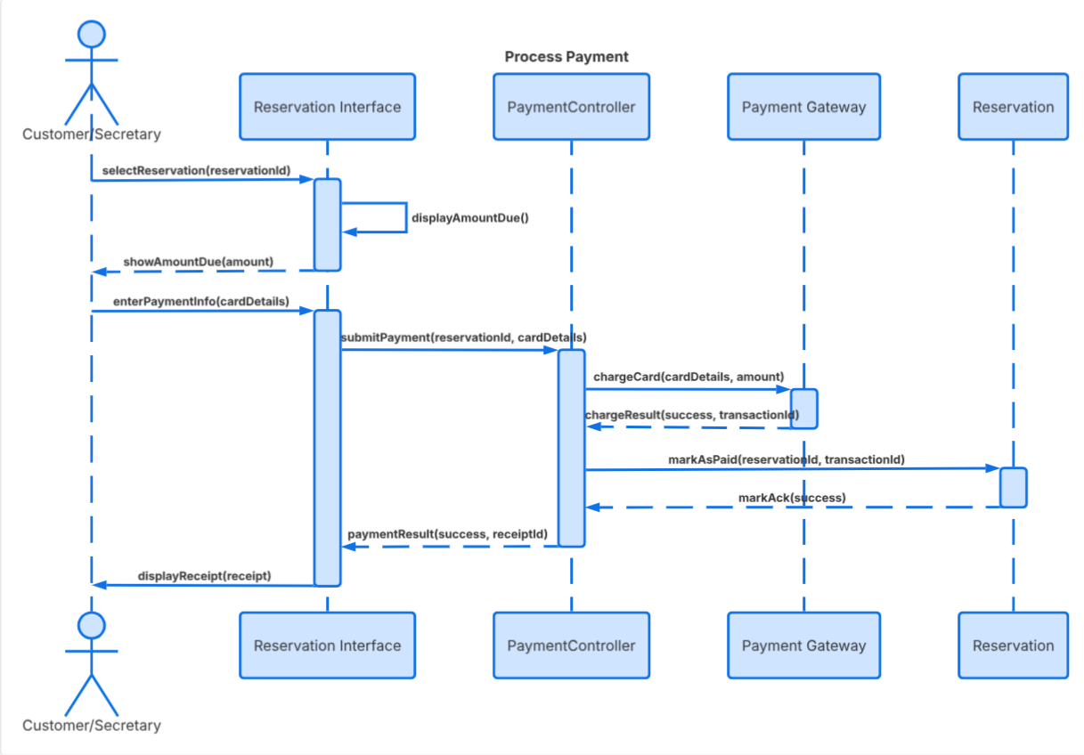

UML Class Diagram
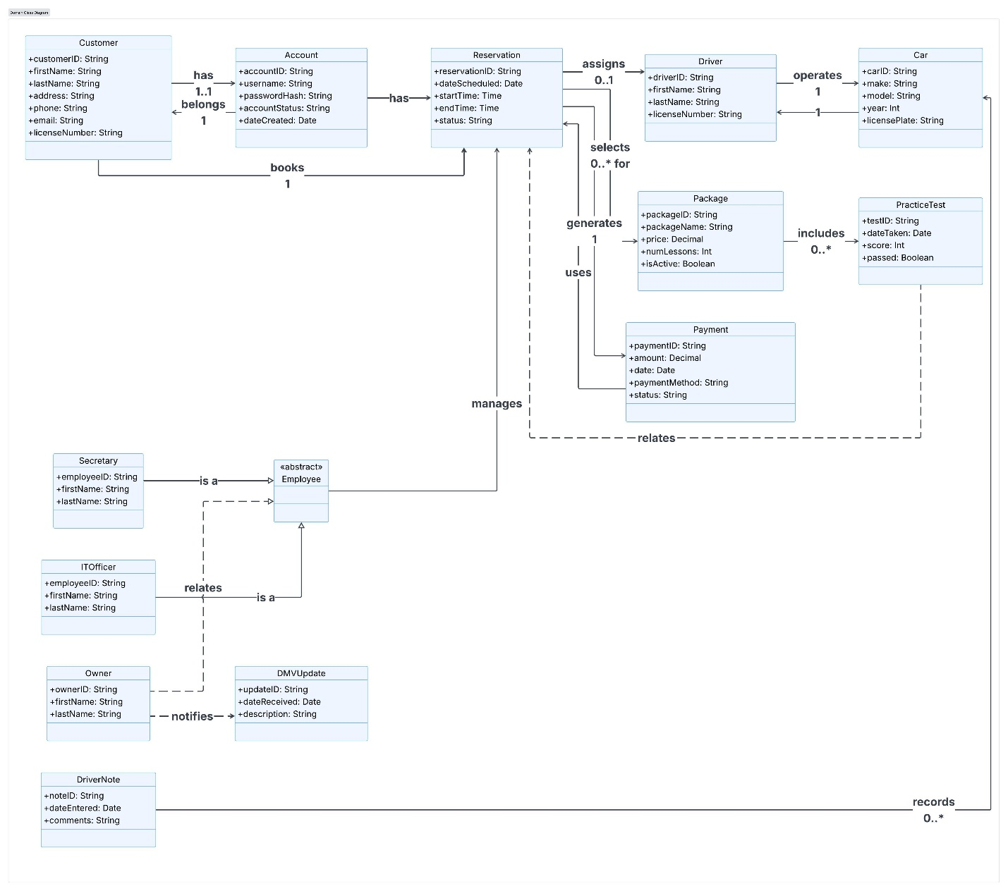

Technical Requirements

Hardware Requirements
- A cloud-hosted application server to run the DriverPass system so the secretary, customers, and IT officer can all access it without DriverPass needing to maintain physical server hardware in house.
- A database server with ample storage to hold records, reservations, payment history, and practice test results as the business grows.
- Workstations or tablets at the front desk for the secretary to manage reservations and process payments in a addition to a computer for the IT officer to manage accounts and packages.

Software Requirements
- A relational database management system to store and manage data in a structured way that supports the relationships shown in the class diagram.
- A web application framework to build the customer facing registration, scheduling, and payment screens.
- A payment integration to securely process credit card transactions.
- Email service integration to send confirmation emails after registration and receipts after payment.

Infrastructure and Tools
- HTTPS/TLS encryption across the whole application so customer personal information and payment data are protected.
- Regular automated database backups so data can be recovered if something goes wrong.
- Role based account access so one can only see and do what their role is supposed to allow.
- A stable internet connection at the DriverPass office since the system is cloud hosted and front desk operations depend on it being reachable.
Together, these requirements support everything shown in the use case, activity, sequence, and class diagrams. This combination will give the development team a starting point for choosing specific vendors and tools once the project moves into implementation.

